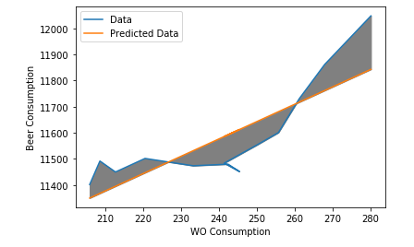

The WO Consumption appears to be correlated, but not very much so. The R² is below 0.7, which indicates a low correlation.